NATO and EDA co-organise Air-to-Air Refuelling conference

Brussels - 29 August, 2019

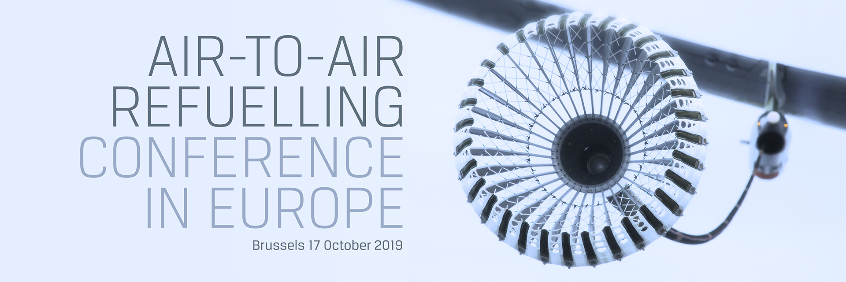

**On 17 October 2019, NATO and the European Defence Agency (EDA) will co-organise for the first time a joint Air-to-Air Refuelling (AAR) conference in Europe.**

The conference will bring together key decision-makers from the EU and NATO as well as the wider transatlantic and international AAR community, including industry, to discuss current and future challenges and coordinate efforts in this important domain. The global dimension of the solutions at hand to resolve remaining shortfalls and the role of industry will also be debated.

Confirmed speakers include, among many others, NATO’s Assistant Secretary General for Defence Investment, Camille Grand, and the EDA Chief Executive, Jorge Domecq as well as the Chairman of the Aerial Refuelling Systems Advisory Group (ARSAG), General John Sams, and high-level representatives from Member States and industry.

During last year’s first AAR conference organised in Europe by EDA, the focus was on ensuring awareness about remaining shortfalls in AAR. This year’s co-organised event will focus on increasing interoperability and will involve industry/manufacturers to debate their role in this process.

Attendance to the conference is upon invitation only.